**PROBLEM 1 Simulation**

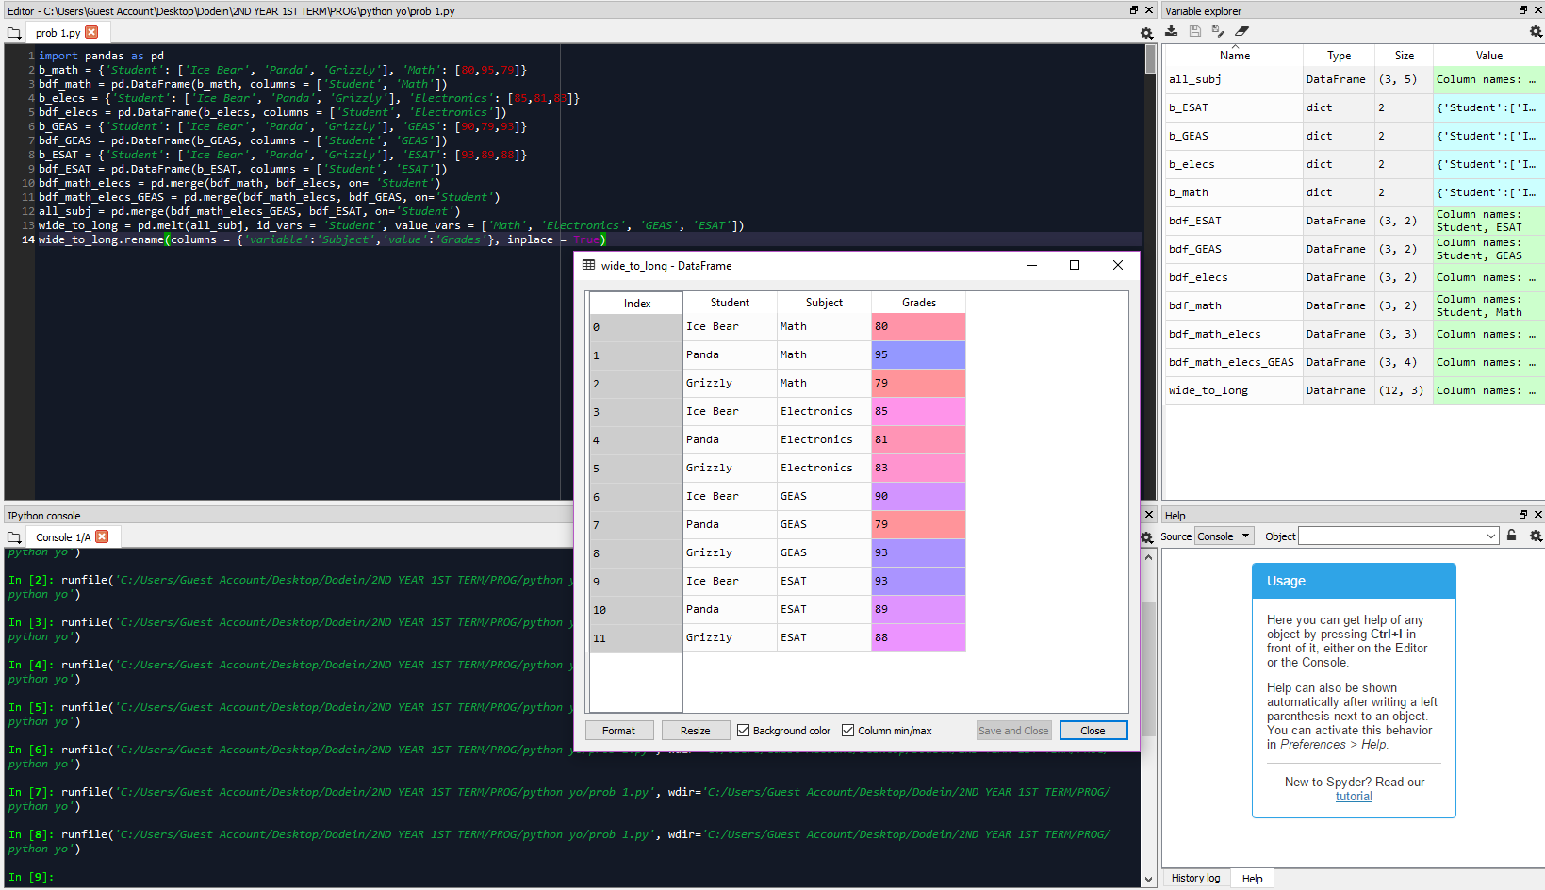-all four separate data frames were merged into one

-the data frame was converted from wide to long format, where the new columns were named as ‘Subject’ and ‘Grades’

**PROBLEM 2 Simulation**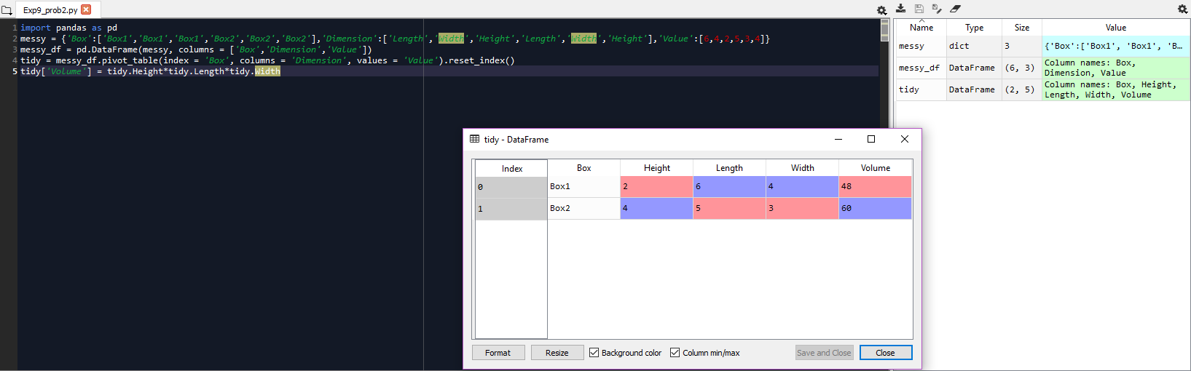

-the messy data frame was tidied where the components of ‘Dimension’ had their respective columns

-a single column [‘Volume’] was added, which contained the values from the product of the three dimensions namely length, width and height